**At-home toothbrushing behaviors of power/electric toothbrush users - a video observation study** ( 3900 words)

**Affiliations:** Mohammed Essalat,Sumukh Kak*** E Jun Chang** , , Isabel Roig Penso****Rachel J. Kulchar*, Doug Morrison, Vivek Shetty.

*Department of Chemistry, Princeton University, Frick Laboratory, Princeton, NJ 08544, USA

**Herman Ostrow School of Dentistry of USC, Los Angeles, CA, 90089, USA

***Department of Psychology, University of California, Los Angeles, CA, 90024, USA

****Department of Statistics, University of California, Los Angeles, CA, 90024, USA

**Keywords**: young adults, video observation, oral hygiene behavior, power toothbrush, dental recommendations

**Abbreviations**

ADA American Dental Association

SE Standard Error

CI Confidence Interval

# Abstract

There are many recommendations by dental professionals on brushing, however it is not clear which of these recommendations are met by individuals brushing at the convenience of their homes. In this paper, we analyze toothbrushing behavior of young adults who use electric toothbrushes, with focus on three metrics: total brushing duration of a brushing session, duration of brushing each dental region, and duration of brushing each dental region with excessive pressure. We designed Oralytics, an application that could collect data from the embedded sensors in the Oral-B® Genius X electric toothbrushes via Bluetooth. These sensors included motion sensors (accelerometer and gyroscope) as well as the pressure sensor embedded in the brush. We successfully collected data from 13 right-handed participants who brushed their teeth for 10 brushing sessions each. These sessions were labeled with a fine-grained resolution using the concurrent video recording of the participants’ faces while brushing to serve as the ground truth of the dental regions that were being brushed during the brushing session. We have analysed this data on study population-level, participant-level and session-level to find the improper brushing behaviors for the population and individuals. We found that however most of our study population brushes for almost the two minutes recommended brushing time (117.08 seconds for an average person), they brush unevenly as they spend brushing buccal teeth surfaces 2.65 and 2.87 times as long as the lingual and occlusal surfaces, respectively. Also, some dental regions, especially occlusal surfaces, are brushed with excessive pressure. Particularly, occlusal surfaces are brushed with excessive pressure 1.52 and 1.46 times as long as the buccal and lingual surfaces. We also observed high inter-subject variability in brushing behaviors, suggesting the importance of individualized brushing recommendations.

# Introduction

Dental caries and periodontal disease are very common chronic diseases closely linked to inadequate oral hygiene behaviors. Considerable scientific evidence indicates that regular and systematic toothbrushing prevents accumulation of dental plaque (a sticky film containing bacteria) that leads to gum disease, tooth decay and eventually, tooth loss (Löe, 2000; American Dental Association; Attin and Hornecker, 2005). Thus, most efforts to reduce the incidence and impact of dental disease focus on toothbrushing techniques and strategies that reduce the accumulation of plaque. Although manual tooth brushes are the most commonly used tools for plaque control, electric toothbrushes are gaining increasing acceptance as alternatives, especially for children, people with disabilities or limited mobility, and older adults. Electric toothbrushes do most of the work, are considered more effective at removing plaque from hard-to-reach areas and incorporate timers to reinforce brushing duration (refs).

Despite the compelling technological features, there is little evidence that electric toothbrushes allow brushing and plaque removal in a manner more structured and systematic than manual brushes. To be effective, all dental surfaces need to cleaned frequently and adequately, otherwise the practical value of toothbrushing is low. Brushing frequency, duration and technique are key determinants of adequate plaque reduction. Common brushing techniques such as the Bass, Stillman and Charter techniques are based on manual toothbrushes and do not readily translate to brushing with electric toothbrushes where the user guides but does not animate the brush head. Studies that have attempted to clarify brushing patterns with electric toothbrushes have largely focused on inter-individual variations determined through video recordings obtained in controlled clinical settings. Such snapshot observations ignore intra-participant variations in brushing behaviors and patterns; the external validity of the structured assessments suffers because the brushing behaviors and patterns recorded in research settings may not be entirely natural.

To clarify natural brushing patterns with electric toothbrushes, we conducted a naturalistic study of brushing behaviors of individuals in their home settings. Sensors embedded within the electric toothbrush and a smartphone application for video recording ensured different data sampling windows and data fidelity. Our objective was to gather accurate data on habitual brushing patterns using electric toothbrushes with a focus on the duration of each session, the brushing sequence, dental areas covered, and the episodes of excessive pressure applied. By examining habitual brushing patterns at the individual and session-level, we sought to clarify inter- and intra-individual variability in brushing practices using electric toothbrushes.

# Materials and Methods

This sub-study was conducted a part of a larger study involving machine learning approaches to characterize brushing behaviors and develop a brushing efficiency score. As part of the parent study, 12 health young participants provided their brushing data in the home setting over three weeks (50 sessions each). The study protocol was reviewed and approved by the Institutional Review Board.

## Data Collection Infrastructure

To allow objective, individual-level and ecologically-valid data on oral hygiene behaviors, we deployed the Remote Oral Behaviors Assessment System (ROBAS) described previously (ref). Briefly, ROBAS builds on a broadly available consumer-grade electric toothbrush (Oral-B Genius X; Procter & Gamble) as the data source for brushing behaviors (timing, duration, pressure applied). Brushing data captured by the accelerometer, gyroscope and pressure sensor contained within the electric brush is transmitted over BLE (Bluetooth Low Energy) to a paired smartphone (Android or Apple) running the companion data collection app. Collected data is then uploaded to a secure cloud server for remote monitoring of data yields and analytics. Visualization of time series data streams of brushing episodes and remote monitoring of sensor function and participant compliance is accomplished through an adaptation of the open platform Grafana dashboard.

## Data Collection

Figure 1 summarizes the data collection process. Upon enrollment, each participant was provided an Oral B brush, a dedicated study phone for video recording, a suction-cup phone mount, chargers, and quick start instructions. Participants downloaded the study-specific app onto their own smartphone and paired it to the electric brush. Participants were instructed to mount the study phone to their bathroom mirror for the duration of the study (3 weeks). At the start of each brushing session, participants launched the study app and activated the front-facing camera on the study phone which help center the participant’s face within the frame. The video recording captured all aspects of the brushing session. Data from the embedded sensors was buffered by the eBrush and transmitted to the study phone via Bluetooth. Turning off the toothbrush ended data collection and triggered the app to save the timestamped brushing data. The brushing session data and the corresponding session video were then uploaded via the ROBAS platform to a secure cloud server for subsequent analysis. The ROBAS platform with integrated analytics, dashboards (GrafanaTM), and alerts rules engine allowed research staff to remotely monitor data feeds, and conduct quality checks.

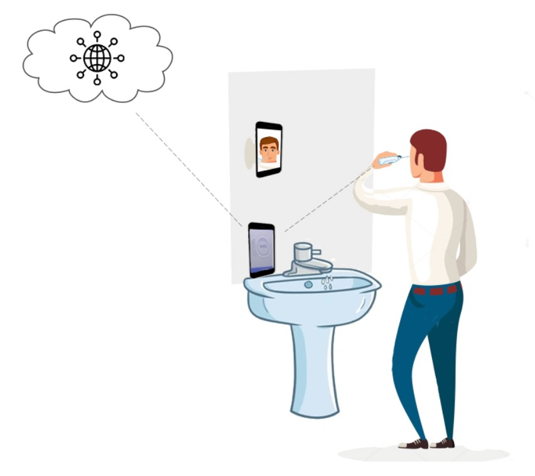

Figure 1: Data collection setup

## Data Processing and Annotation

We randomly selected 10 recorded sessions (out of 50 recorded sessions) from each participant for a total of 120 brushing sessions. To establish ground truth information, trained and calibrated student researchers reviewed and annotated the individual video recordings, focusing on tooth surface coverage as well as brushing duration of each surface. Every epoch of brushing a tooth surface that lasted more than 0.5 seconds was labeled. Because the study phone camera recorded at 1080 p at 30 fps (frames-per-second), we were be able to get a 33 ms time resolution for the ground truth data. The annotated video timestamps were then aligned with the sensor signal time stamps. An experienced examiner verified usable sessions and conducted random audits of labeled data and provided feedback on systematic errors

Dental surfaces were divided into dividing them into 16 regions (Figure 3) using the convention proposed by Lee et al. (ref). Bnriefly, dental surfaces are divided into maxillary (upper jaw) versus mandibular (lower jaw), right versus left versus anterior (middle) sides, and each of the teeth surfaces has buccal (outside), lingual (inside), and occlusal (flat) surfaces (expect for the anterior teeth surfaces that only have buccal and lingual sides).

# 

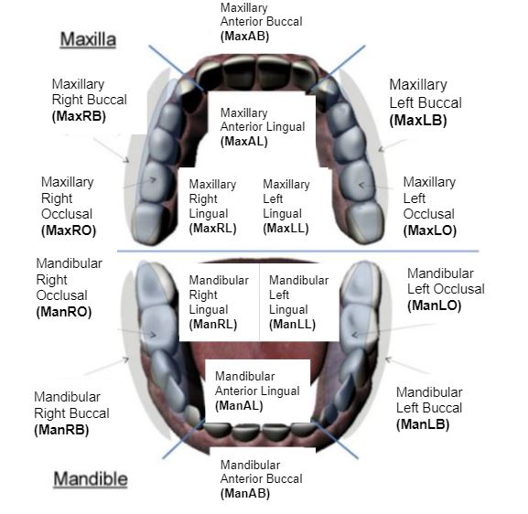

**Fig 3.** 16 dental surfaces (image retrieved from []) considered in this study.

## Analyses

All statistical analysis was performed using Matlab R2021a (ref). The dataset used as well as the code to generate the results are publicly available publicly at in a GitHub repository [].

To capture inter- and intra-subject variabilities, we modeled the brushing duration using a Poisson regression model with a log link function and random effects by participant ID (both on intercept and on dental surfaces) and session ID (on intercept). We also represented the data using a zero-inflated Poisson regression model [] with fixed effects to account for regions skipped during brushing or not brushed with excessive pressure (see S1 appendix for details)

To examine the data on different levels, we used boxplots. Data points were labeled as outliers if they were not in the range of [q1 - w * (q3-q1) , q3 + w * (q3-q1)]; in which w is the Whisker value and q1 and q3 are the 25th and 75th percentiles of the sample data, respectively. We used a whisker value of ±2.7σ (σ is the standard deviation of the sample data) that corresponds to the coverage of 99.3% of the data, if the data is normally distributed.

# Results

The 12 participants comprised of eight females and four males with ages ranging from 18 to 23 years (20.77 ± 1.59).

**Total active brushing duration in each session:** We calculated the effective brushing duration by excluding pauses in brushing and the times transitioning the brush head to different regions. Figure 4 summarizes the active brushing duration for all participants. Most of the participants (91.67%) brushed less than the recommended two minutes in all their sessions. The mean brushing duration for an average participant was 84.47 seconds.

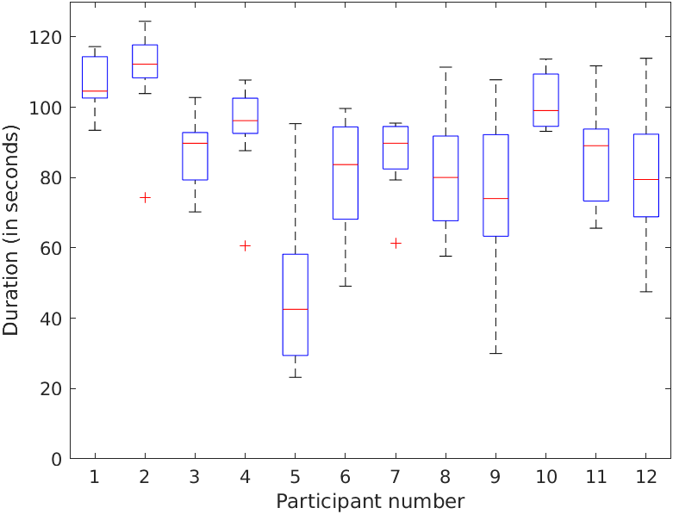

**Fig 4.** Active brushing session duration of all participants.

There was substantial inter- and intra-individual variability in brushing duration. Some participants (e.g. # 1 and 2) brushed for almost two minutes across sessions whereas others (e.g. participant 5) brushed for less than a minute (Mean inter-individual variability = 16.64 seconds). Some participants (e.g., 2, 4, and 7) brushed consistently for nearly the same duration of time; others (e.g., # 5, 9, and 12) varied greatly (> 70 seconds) in their brushing duration (Mean intra-participant variability = 15.27 seconds).

**Brushing duration for each dental surface:** Figure 5 summarizes the duration of brushing of each surface for all participants. MaxAB, MaxLB, and MaxRB were the areas brushed the longest with a median of 10.68, 8.78, and 8.22 seconds respectively. In contrast, MaxLL and MaxLO were frequently skipped during brushing.

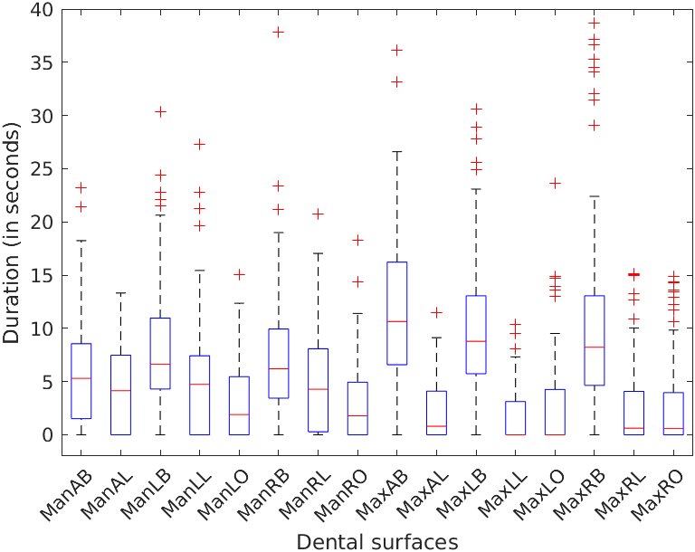

**Fig 5.** Group-level boxplot of brushing time of all 16 dental surfaces

Brushing time categorized by different regions is shown in Fig 6. Participants did not vary significantly in the brushing times spent on different sides (right, anterior, and left) or the maxillary and mandibular regions. However, participants differed in the times spent brushing various teeth surfaces with buccal surfaces brushed significantly more than the lingual and occlusal surfaces of the teeth. On average, buccal surfaces were brushed 5.57 times longer than the lingual surfaces (95% CI 1.69, 18.33; p < 0.001) and 4.68 times longer the occlusal surfaces (95% CI 2.52, 8.71; p < 0.001).

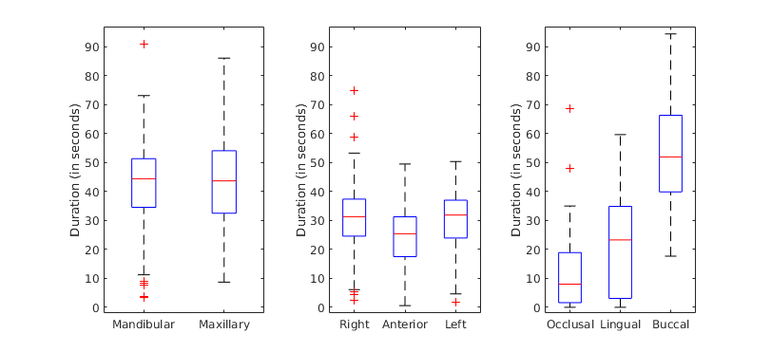

**Fig 6.** Group-level boxplot of brushing time of different dental surfaces

There was considerable inter-individual variability in terms of brushing time devoted to different surfaces. Some participants (e.g. # 4) brushed the dental surfaces on the left side of their mouth, substantially more than the right side whereas other participants (e.g. # 7) do the opposite (Fig 7). Others (e.g. #11), neglected their lingual surfaces or their (e.g. # 9) occlusal surfaces (Fig 8). Similar variability was observed for the maxillary and mandibular regions (Fig 9).

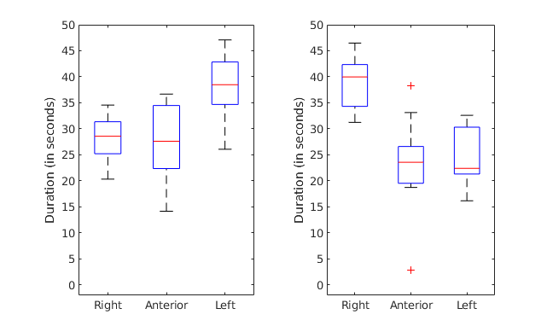

**Fig 7.** Inter-subject variability of brushing duration on right, anterior and left surfaces. Participant 4 (on the left) brushes their left surfaces more than their anterior left surfaces and participant 7 (on the right) brushes their right surfaces more than the rest.

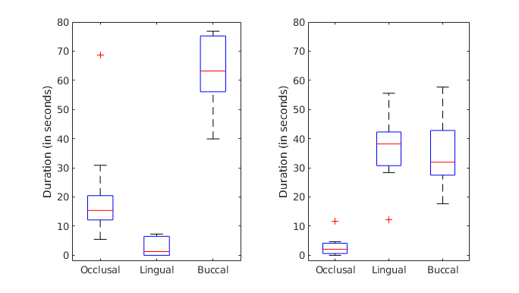

**Fig 8.** Inter-subject variability of brushing duration on occlusal, lingual and buccal surfaces. Participant 11 (on the left) brushes their lingual surfaces much less than their buccal and occlusal surfaces and participant 9 (on the right) brushes their occlusal surfaces very little.

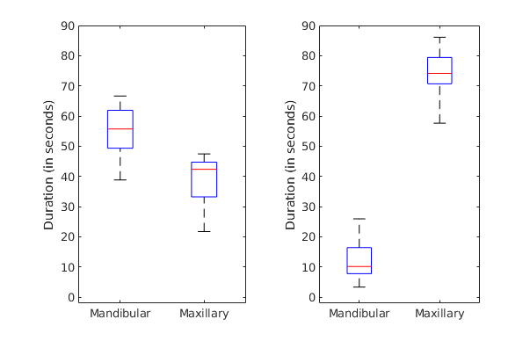

**Fig 9.** Inter-subject variability of brushing duration on mandibular and maxillary surfaces. Participant 4 (on the left) brushes their mandibular surfaces substantially more than their maxillary surfaces and participant 7 (on the right) brushes their maxillary surfaces more.

**Epochs of excessive rushing pressure:** Figure 10 summarizes the episodes of excess brushing pressure per region. In general, the occlusal surfaces were often brushed with excessive pressure.

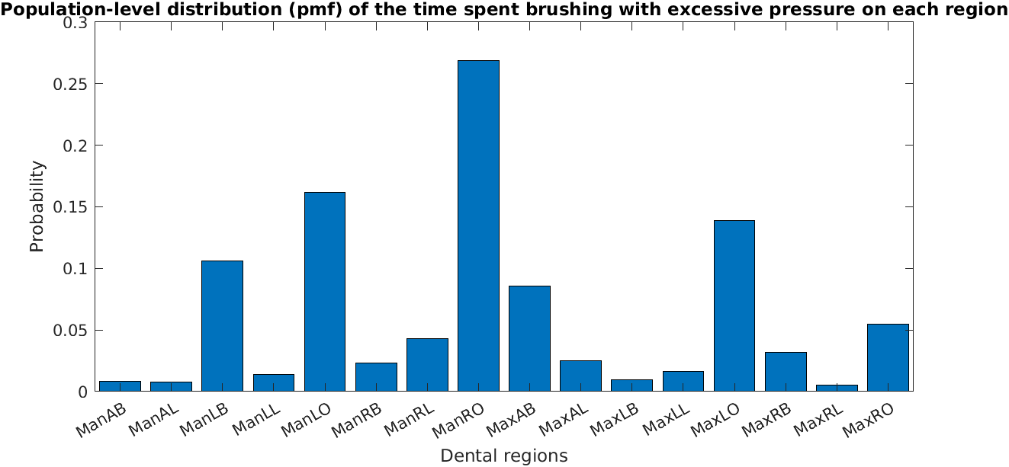

**Figure 10.** Group-level duration of brushing with excessive pressure on the 16 dental regions.

Some participants were capable of consistently brushing with normal pressures, others (#6 and 11) tended to apply excessive pressure in brushing certain regions.

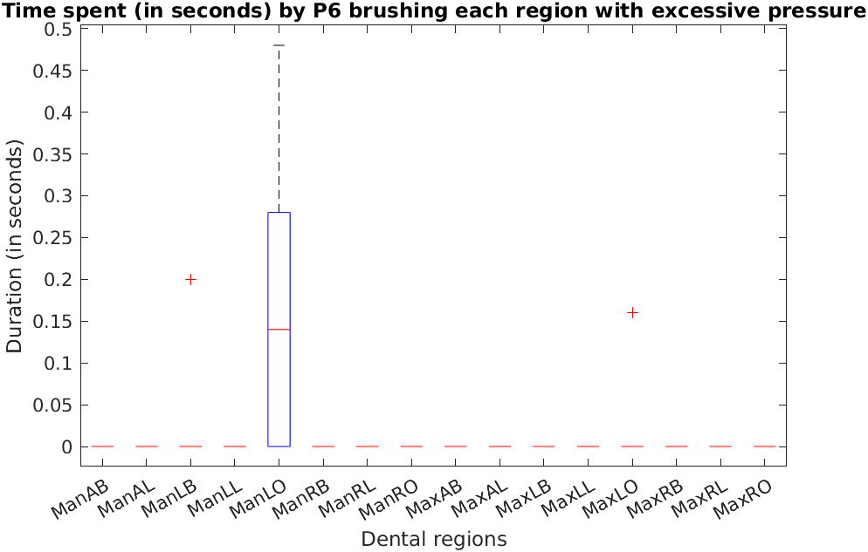 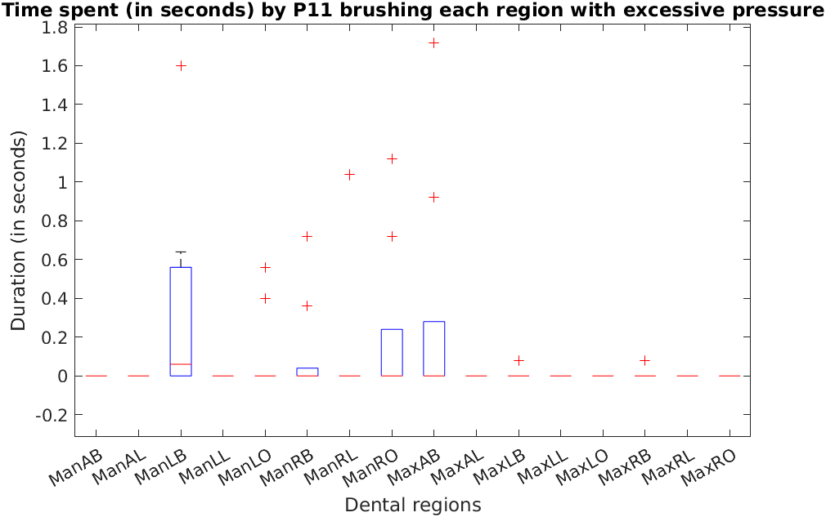

**Figure 8.** Intra-subject and inter- subject variability of excessive pressure during brushing

# Discussion

1. High level summary of findings
2. Contextualize finding to other studies
3. Discuss potential weaknesses

Since people seem to follow a habitual brushing pattern, merely instructing people to follow standard brushing techniques is simply not enough. Instead, it is essential to note individualized brushing flaws and parlay those inadequacies to each tooth brusher. In this study we use a

In this paper, we discussed brushing behavior by conducting a study consisting of 13 right-handed individuals brushing their teeth for 10 brushing sessions over three weeks. We collected data from embedded sensors in the participants' electric toothbrushes as well as the video recordings of their faces while brushing. We analyzed the collected data with regard to three factors of brushing session duration, duration of time spent on each dental region, and the duration of time spent with excessive pressure on each dental region. Our analysis was performed on study population-level, participant-level and session-level to help extract general as well as individual dental recommendations. In particular, we found that our study population brush their buccal teeth surfaces significantly more than other teeth surfaces and we found that they significantly brush their occlusal teeth surfaces with excessive pressure. We also observed huge inter-subject variations in the brushing factors that we analysed, which emphasized on a need for individualized dental recommendations. We found that although most of our participants brush around two minutes recommended brushing time, they perform poorly on distributing this time evenly on all the teeth surfaces. Hence, brushing habits deviate from optimal practice not only because of inadequate time spent brushing the mouth, but also due to the uneven distributions of time spent brushing different dental regions and the use of excessive pressure during toothbrushing.

**Acknowledgement**

This research was made possible by…

**References**

[Ainamo, J. 1971. “The Effect of Habitual Toothcleansing on the Occurrence of Periodontal Disease and Dental Caries.” *Suomen Hammaslaakariseuran Toimituksia = Finska Tandlakarsallskapets Forhandlingar* 67 (1): 63–70.](https://www.zotero.org/google-docs/?290hWS)

[Andlaw, R. J. 1978. “Oral Hygiene and Dental Caries--a Review.” *International Dental Journal* 28 (1): 1–6.](https://www.zotero.org/google-docs/?290hWS)

[Bellini, Hamilton Taddei, Pål Arneberg, and Frithjof R. Von Der Fehr. 1981. “Oral Hygiene and Caries: A Review.” *Acta Odontologica Scandinavica* 39 (5): 257–65. https://doi.org/10.3109/00016358109162287.](https://www.zotero.org/google-docs/?290hWS)

[Berenie, James, Louis W. Ripa, and Gary Leske. 1973. “THE RELATIONSHIP OF FREQUENCY OF TOOTHBRUSHING, ORAL HYGIENE, GINGIVAL HEALTH, AND CARIES-EXPERIENCE IN SCHOOL CHILDREN.” *Journal of Public Health Dentistry* 33 (3): 160–71. https://doi.org/10.1111/j.1752-7325.1973.tb00656.x.](https://www.zotero.org/google-docs/?290hWS)

[Çakur, Binali, Mehmet Yildiz, Şenol Dane, and Yahya Orçun Zorba. 2011. “The Effect of Right or Left Handedness on Caries Experience and Oral Hygiene.” *Journal of Neurosciences in Rural Practice* 02 (01): 040–042. https://doi.org/10.4103/0976-3147.80093.](https://www.zotero.org/google-docs/?290hWS)

[“Caries Incidence and Lesion Progression from Adolescence to Young Adulthood: A Prospective 15-Year Cohort Study in Sweden.” 2004. *British Dental Journal* 197 (1): 28–28. https://doi.org/10.1038/sj.bdj.4811413.](https://www.zotero.org/google-docs/?290hWS)

[Costa, Fernando Oliveira, Luís Otávio Miranda Cota, Eugênio José Pereira Lages, Gislene Clemente Vilela Câmara, Sheila Cavalca Cortelli, José Roberto Cortelli, José Eustáquio Costa, and Telma Campos Medeiros Lorentz. 2011. “Oral Impact on Daily Performance, Personality Traits, and Compliance in Periodontal Maintenance Therapy.” *Journal of Periodontology* 82 (8): 1146–54. https://doi.org/10.1902/jop.2011.100515.](https://www.zotero.org/google-docs/?290hWS)

[Creeth, Jonathan E., Andrew Gallagher, Joseph Sowinski, James Bowman, Kathy Barrett, Shirley Lowe, Kartik Patel, and Mary Lynn Bosma. 2009. “The Effect of Brushing Time and Dentifrice on Dental Plaque Removal in Vivo.” *Journal of Dental Hygiene: JDH* 83 (3): 111–16.](https://www.zotero.org/google-docs/?290hWS)

[Dale, John W. 1969. “Toothbrushing Frequency and Its Relationship to Dental Caries and Periodontal Disease.” *Australian Dental Journal* 14 (2): 120–23. https://doi.org/10.1111/j.1834-7819.1969.tb04290.x.](https://www.zotero.org/google-docs/?290hWS)

[Deinzer, Renate, Stefanie Ebel, Helen Blättermann, Ulrike Weik, and Jutta Margraf-Stiksrud. 2018. “Toothbrushing: To the Best of One’s Abilities Is Possibly Not Good Enough.” *BMC Oral Health* 18 (1): 167. https://doi.org/10.1186/s12903-018-0633-0.](https://www.zotero.org/google-docs/?290hWS)

[Ebel, S., H. Blättermann, U. Weik, J. Margraf-Stiksrud, and R. Deinzer. 2019. “High Plaque Levels after Thorough Toothbrushing: What Impedes Efficacy?” *JDR Clinical & Translational Research* 4 (2): 135–42. https://doi.org/10.1177/2380084418813310.](https://www.zotero.org/google-docs/?290hWS)

[Ganss, C., R. Duran, T. Winterfeld, and N. Schlueter. 2018. “Tooth Brushing Motion Patterns with Manual and Powered Toothbrushes—a Randomised Video Observation Study.” *Clinical Oral Investigations* 22 (2): 715–20. https://doi.org/10.1007/s00784-017-2146-7.](https://www.zotero.org/google-docs/?290hWS)

[Janusz, Karen, Bruce Nelson, Robert D. Bartizek, Patricia A. Walters, and Aaron R. Biesbrock. 2008. “Impact of a Novel Power Toothbrush with SmartGuide Technology on Brushing Pressure and Thoroughness.” *The Journal of Contemporary Dental Practice* 9 (7): 1–8.](https://www.zotero.org/google-docs/?290hWS)

[Lee, Hee-Kyung, Sang-Hee Choi, Kyu Chang Won, Anwar T. Merchant, Keun-Bae Song, Seong-Hwa Jeong, Sung-Kook Lee, and Youn-Hee Choi. 2009. “The Effect of Intensive Oral Hygiene Care on Gingivitis and Periodontal Destruction in Type 2 Diabetic Patients.” *Yonsei Medical Journal* 50 (4): 529. https://doi.org/10.3349/ymj.2009.50.4.529.](https://www.zotero.org/google-docs/?290hWS)

[Litonjua, Luis A., Sebastiano Andreana, Peter J. Bush, Thomas S. Tobias, and Robert E. Cohen. 2004. “Wedged Cervical Lesions Produced by Toothbrushing.” *American Journal of Dentistry* 17 (4): 237–40.](https://www.zotero.org/google-docs/?290hWS)

[Löe, Harald. 2000. “Oral Hygiene in the Prevention of Caries and Periodontal Disease.” *International Dental Journal* 50 (3): 129–39. https://doi.org/10.1111/j.1875-595X.2000.tb00553.x.](https://www.zotero.org/google-docs/?290hWS)

[Macgregor, I. D. M., and A. J. Rugg-Gunn. 1979. “Survey of Toothbrushing Duration in 85 Uninstructed English Schoolchildren.” *Community Dentistry and Oral Epidemiology* 7 (5): 297–98. https://doi.org/10.1111/j.1600-0528.1979.tb01235.x.](https://www.zotero.org/google-docs/?290hWS)

[Mathur, Vijay Prakash, and Jatinder Kaur Dhillon. 2018. “Dental Caries: A Disease Which Needs Attention.” *The Indian Journal of Pediatrics* 85 (3): 202–6. https://doi.org/10.1007/s12098-017-2381-6.](https://www.zotero.org/google-docs/?290hWS)

[Menghini, G. D., M. Steiner, T. M. Marthaler, and R. M. Weber. 2001. “[Decline of caries prevalence in Swiss military recruits between 1970 and 1996].” *Schweizer Monatsschrift Fur Zahnmedizin = Revue Mensuelle Suisse D’odonto-Stomatologie = Rivista Mensile Svizzera Di Odontologia E Stomatologia* 111 (4): 410–16.](https://www.zotero.org/google-docs/?290hWS)

[Pita-Fernández, Salvador, Antonio Pombo-Sánchez, Juan Suárez-Quintanilla, Silvia Novio-Mallón, Berta Rivas-Mundiña, and Sonia Pértega-Díaz. 2010. “Relevancia clínica del cepillado dental y su relación con la caries.” *Atención Primaria* 42 (7): 372–79. https://doi.org/10.1016/j.aprim.2009.10.014.](https://www.zotero.org/google-docs/?290hWS)

[Rugg-Gunn, A. J., and I. D. M. Macgregor. 1978. “A Survey of Toothbrushing Behaviour in Children and Young Adults.” *Journal of Periodontal Research* 13 (4): 382–89. https://doi.org/10.1111/j.1600-0765.1978.tb00193.x.](https://www.zotero.org/google-docs/?290hWS)

[Serino, Giovanni, Jan L. Wennstrom, Jan Lindhe, and Lennart Eneroth. 1994. “The Prevalence and Distribution of Gingival Recession in Subjects with a High Standard of Oral Hygiene.” *Journal of Clinical Periodontology* 21 (1): 57–63. https://doi.org/10.1111/j.1600-051X.1994.tb00278.x.](https://www.zotero.org/google-docs/?290hWS)

[Shetty, Vivek, Douglas Morrison, Thomas Belin, Timothy Hnat, and Santosh Kumar. 2020. “A Scalable System for Passively Monitoring Oral Health Behaviors Using Electronic Toothbrushes in the Home Setting: Development and Feasibility Study.” *JMIR MHealth and UHealth* 8 (6): e17347. https://doi.org/10.2196/17347.](https://www.zotero.org/google-docs/?290hWS)

[Stenlund, Hans, Ingegerd Mejàre, and Carina Källestål. 2003. “Caries Incidence Rates in Swedish Adolescents and Young Adults with Particular Reference to Adjacent Approximal Tooth Surfaces: A Methodological Study: **Caries Rates of Adjacent Approximal Tooth Surfaces**.” *Community Dentistry and Oral Epidemiology* 31 (5): 361–67. https://doi.org/10.1034/j.1600-0528.2003.00015.x.](https://www.zotero.org/google-docs/?290hWS)

[Tezel, Adnan, Recep Orbak, and Varol Çanakçi. 2001. “The Effect of Right or Left-Handedness on Oral Hygiene.” *International Journal of Neuroscience* 109 (1–2): 1–9. https://doi.org/10.3109/00207450108986521.](https://www.zotero.org/google-docs/?290hWS)

[Van der Weijden, G. A., M. F. Timmerman, P. A. Versteeg, M. Piscaer, and U. Van der Velden. 2004. “High and Low Brushing Force in Relation to Efficacy and Gingival Abrasion.” *Journal of Clinical Periodontology* 31 (8): 620–24. https://doi.org/10.1111/j.1600-051x.2004.00529.x.](https://www.zotero.org/google-docs/?290hWS)

[Versteeg, P. A., M. F. Timmerman, M. Piscaer, U. Van der Velden, and G. A. Van der Weijden. 2005. “Brushing with and without Dentifrice on Gingival Abrasion.” *Journal of Clinical Periodontology* 32 (2): 158–62. https://doi.org/10.1111/j.1600-051X.2005.00652.x.](https://www.zotero.org/google-docs/?290hWS)

[Winterfeld, T., N. Schlueter, D. Harnacke, J. Illig, J. Margraf-Stiksrud, R. Deinzer, and C. Ganss. 2015. “Toothbrushing and Flossing Behaviour in Young Adults—a Video Observation.” *Clinical Oral Investigations* 19 (4): 851–58. https://doi.org/10.1007/s00784-014-1306-2.](https://www.zotero.org/google-docs/?290hWS)

**Funding**

This research was supported by...

**Conflicts of Interest**

The authors declare no conflict of interest.

# **Appendix**

## Section 1. Brushing duration on each dental region

We model the brushing duration (in terms of number of samples received) on each dental region as a poisson random variable. With proper postprocessing, we account for missing Bluetooth packets to have an exact 25Hz sampling rate for our sensors. Hence, 25 samples are equivalent to one second of brushing duration. We modeled the brushing samples $Y_{ijk}$ of participant $i∈1:13$ during the brushing session $j∈1:10$ on dental region $k∈1:16$, with a Poisson mixed-effects model as follows:

$Y_{ijk} 〜 Pois (λ_{ijk})$ (eq. 1)

$$log(E(Y_{ijk})) = log(λ_{ijk}) = β_{0} + β_{Mi}1_{\{k ∈ M\}} +β_{Ai}1_{\{k ∈ A\}} +β_{Gi}1_{\{k ∈ G\}} +β_{Oi}1_{\{k ∈ O\}} +β_{Li}1_{\{k ∈ L\}} + α_{i} + γ_{ij}$$

(eq. 2)

$$β_{Mi} 〜 N(0, {σ_{M}}^{2})$$

$α_{i} 〜 N(0, {{σ_{α}}^{2})}^{}$ (eq. 3)

$$γ_{ij} 〜 N(0, {{σ_{γ}}^{2})}^{}$$

In which, we assumed random effects for participants and sessions with variances ${σ_{α}}^{2}$ and ${σ_{γ}}^{2}$, respectively. We chose a log link between the the mean (expectation $E(.)$) of the random variable $Y_{ijk}$ and our dummy variables which are defined as follows:

$M$: the set of maxillary (upper jaw) regions

$A$: the set of anterior regions

$G$: the set of left side (“gauche”) regions

$O$: the set of occlusal regions

$L$: the set of lingual regions

By fitting this model to our data set, we find the estimated coefficients summarized in Appendix table 1. We used matlab R2021a generalized mixed-effects model for our analysis.

|  |  |  |  |  |
| --- | --- | --- | --- | --- |
| Variable name | Estimate | SE | P-value | CI |
| $$β_{0}$$ | 5.323 | 0.0789 | <0.001 | [5.168, 5.4776] |
| $$β_{M}$$ | 0.048 | 0.0038 | <0.001 | [0.0406, 0.0557] |
| $$β_{A}$$ | -0.067 | 0.0050 | <0.001 | [-0.0767, -0.0572] |
| $$β_{G}$$ | -0.035 | 0.0045 | <0.001 | [-0.0435, -0.0257] |
| $$β_{L}$$ | -0.973 | 0.0047 | <0.001 | [-0.9821, -0.9638] |
| $$β_{O}$$ | -1.056 | 0.0058 | <0.001 | [-1.0669, -1.0443] |

**Appendix table 1.** Estimated coefficients of mixed-effects model on brushing duration on dental regions.

The estimated random effects are presented in Appendix table 2.

|  |  |  |  |  |  |  |  |  |  |  |  |  |  |
| --- | --- | --- | --- | --- | --- | --- | --- | --- | --- | --- | --- | --- | --- |
| Variable | $$α_{1}$$ | $$α_{2}$$ | $$α_{3}$$ | $$α_{4}$$ | $$α_{5}$$ | $$α_{6}$$ | $$α_{7}$$ | $$α_{8}$$ | $$α_{9}$$ | $$α_{10}$$ | $$α_{11}$$ | $$α_{12}$$ | $$α_{13}$$ |
| Estimate | 0.279 | 0.303 | 0.088 | 0.155 | -0.565 | -0.014 | 0.079 | 0.020 | -0.090 | 0.233 | 0.073 | -0.003 | -0.554 |
| P-value | <0.01 | <0.01 | 0.40 | 0.14 | <0.01 | 0.89 | 0.45 | 0.85 | 0.39 | 0.03 | 0.49 | 0.98 | <0.01 |

**Appendix table 2.** Estimated participants random effects on duration of brushing on the dental regions

We estimated standard deviations of ${{\hat{ }σ}_{α}=}^{}$ 0.274 and ${{\hat{ }σ}_{γ}}^{}$ = 0.242 for participants and sessions random effects, respectively. Random effects for some participants -- particularly for participants 1, 2, 5, and 13 -- are significant considering the P-values presented in Appendix table 2. Also, random effects for some sessions are significant -- for instance session 5 of participant 2 -- but due to the huge number of such coefficients (130 coefficients) we avoid presenting them here. These results indicate a substantial inter-subject and intra-subject variability in brushing durations on dental regions.

Also, by fitting a fixed-effects model we find coefficients that are close enough to the coefficients estimated in the mixed-effects model and hence using the Hausman test [citation needed], removing the random effects and using the fixed-effects model is justified.

However, if we look at the distribution of the brushing duration on any region as shown in Appendix figure 1 (for the MaxRO dental region), it has an inflation at zero since some regions are skipped in some brushing sessions.

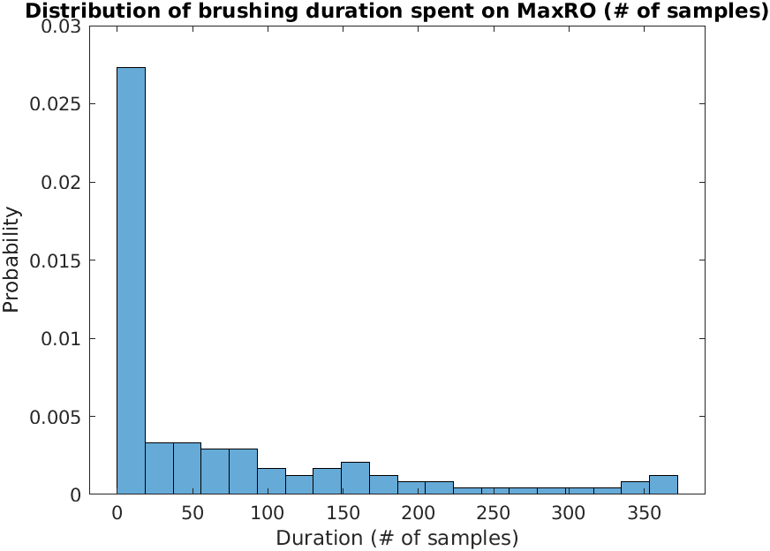

Appendix **figure 1.** Distribution of duration (# of samples) spent on MaxRO

As a result, we also fitted a zero-inflated poisson fixed-effects model defined as follows using the matlab package in [citation needed]:

$Y_{ijk} 〜 \{ 0 with probability p_{ijk} ; Pois (λ_{ijk}) with probability 1-p_{ijk}\}$ (eq. 4)

$log(E(Y_{ijk})) = log(λ_{ijk}) = β_{0} + β_{M}1_{\{k ∈ M\}} +β_{A}1_{\{k ∈ A\}} +β_{G}1_{\{k ∈ G\}} +β_{O}1_{\{k ∈ O\}} +β_{L}1_{\{k ∈ L\}}$

(eq. 5)

$logit (p_{ijk}) = -τ ln (λ_{ijk})$ (eq. 6)

The estimated coefficients are presented in Appendix table 3. All the coefficients except for $β_{A}$ and $β_{G}$ are still significant, confirming our results from the Poisson mixed-effects model. For comparison between brushing the dental regions on the right side versus the left or anterior side of the mouth, our tests do not produce a significant result and hence we cannot state a conclusion about that.

|  |  |  |  |  |  |  |  |
| --- | --- | --- | --- | --- | --- | --- | --- |
| Variable name | $$τ$$ | $$β_{0}$$ | $$β_{M}$$ | $$β_{A}$$ | $$β_{G}$$ | $$β_{L}$$ | $$β_{O}$$ |
| Estimate | 0.206 | 5.367 | 0.119 | -0.030 | -0.020 | -0.492 | -0.571 |
| P-value | <0.001 | <0.001 | 0.003 | 0.309 | 0.340 | <0.001 | <0.001 |

In order to find the P-values of the estimated coefficients in Appendix table 3, we performed a permutation test [citation needed] in which we randomly permuted the response variable (brushing durations) for a significant amount (10000 times) to compute the distribution of each coefficient under the null hypothesis (that coefficient is zero).

## Section 2. Brushing duration with excessive pressure on each dental region

In brushing duration with excessive pressure, we observe even more zeros than in Appendix Section 1, because in a lot of regions there is no excessive pressure. Hence, we model this using the same equations as Appendix Section 1 (eq. 4, eq. 5, and eq. 6), by only changing the response variable from $Y$ to the excessive pressure $Z$. The estimated coefficients are summarized in Appendix table 4. Again, we computed the P-values using the permutation test that was described in Appendix Section 1.

|  |  |  |  |  |
| --- | --- | --- | --- | --- |
| Variable name | Estimate | SE | P-value | CI |
| $$β_{0}$$ | 2.920 |  | 0.9303 |  |
| $$β_{M}$$ | -0.044 |  | 0.4995 |  |
| $$β_{A}$$ | -0.119 |  | 0.3285 |  |
| $$β_{G}$$ | -0.231 |  | 0.1529 |  |
| $$β_{B}$$ | -0.416 |  | 0.0554 |  |
| $$β_{L}$$ | -0.376 |  | 0.0740 |  |

**Appendix table 4.** Estimated coefficients of zero-inflated fixed-effects model on brushing duration with excessive pressure on dental regions.

As can be seen from Appendix table 3, the coefficients for buccal and lingual regions are significant by considering a significance level of 0.1. This indicates that the excessive pressure on occlusal regions is more than the lingual and buccal regions. The rest of the coefficients are non-significant. To compute the standard error and the confidence intervals we bootstrapped the data on the participant level and sessions level.

## Section 3. Duration of total brushing in a brushing session

We model the total brushing duration in a brushing session $D_{ij}$ using a Poisson regression model with random effects for participants as follows:

$D_{ij} 〜 Pois (λ_{i})$ (eq. 7)

$log(E(D_{ij})) = log(λ_{i}) = β_{0} + α_{i}$ (eq. 8)

$α_{i }∼N(0,{σ_{α}}^{2})$ (eq. 9)

Within subject variability: if I brush rn vs I brush at night : mean(sqrt(lambda_i)) was not good, mean(std(each participant))

In between subject variability: if I brush rn vs soemoneelse brushes rn: std(lambda)

The estimated value of $β_{0}$ was ${\hat{β}}_{0}$ = 7.982 ( $SE({\hat{β}}_{0})=$ 0.052; 95% CI: 7.88, 8.09) and the estimated random-effects are listed in Appendix table 5; the estimated standard deviation of the random effects was ${\hat{σ}}_{α}$ = 0.1876 (95% CI: 0.133, 0.291). Some of these random effects are significant (particularly for participants 5, 6, and 13) and hence suggest substantial interpersonal variations in brushing session duration.

|  |  |  |  |  |  |  |  |  |  |  |  |  |  |
| --- | --- | --- | --- | --- | --- | --- | --- | --- | --- | --- | --- | --- | --- |
| Variable | $$α_{1}$$ | $$α_{2}$$ | $$α_{3}$$ | $$α_{4}$$ | $$α_{5}$$ | $$α_{6}$$ | $$α_{7}$$ | $$α_{8}$$ | $$α_{9}$$ | $$α_{10}$$ | $$α_{11}$$ | $$α_{12}$$ | $$α_{13}$$ |
| Estimate | 0.118 | 0.029 | 0.102 | 0.004 | 0.193 | -0.157 | 0.048 | 0.090 | 0.025 | 0.088 | 0.087 | -0.043 | -0.584 |
| P-value | 0.023 | 0.577 | 0.054 | 0.943 | <0.01 | <0.01 | 0.358 | 0.088 | 0.639 | 0.097 | 0.100 | 0.411 | <0.01 |

**Appendix table 5.** Estimated random effects on total brushing duration in a brushing session

Winterfield et al. (2014) concluded that participants only spent 28% of their time brushing oral regions with 40% of participants completely neglecting to brush oral surfaces when using a powered toothbrush [42]. Thus, a higher risk for dental diseases and poor oral hygiene are the consequences of neglecting regions of the mouth when brushing.

In Janusz et al. (2008), 46.3% of the participants who were instructed to brush their teeth as they normally do activated the pressure sensor located in the toothbrush for at least four seconds of the two minute brushing interval, elucidating that brushing with high levels of pressure is common among the general population [30]. Moreover, in examining the amounts of pressure applied to various regions of the mouth during toothbrushing, Versteeg et al. (2005) found that lay people brushing their own teeth applied significantly more pressure and thus elucidated higher levels of gingival abrasion than that of a professional trained in practicing ideal brushing techniques [34]. These same subjects caused significantly less abrasion on the lingual than that of the buccal surface [34], demonstrating the varying degrees of pressure applied to different regions of the mouth. Therefore, this study shows that excessive amounts of pressure during toothbrushing is prevalent and a targeted intervention on pressure for the specific region that is brushed with excessive pressure could be a way to reduce the prevalence of gingival abrasion as a preventative measure.